### Title

DESIGN AND IMPLEMENTATION OF A SAFETY AND HEALTH MANAGEMENT SYSTEM (CCECC NIG. LTD AS CASE STUDY)

BY

DAVID KUNDE

BSU/SC/CMP/19/54286

A PROJECT SUBMITTED TO THE DEPARTMENT OF MATHEMATICS AND COMPUTER SCIENCE, FACULTY OF SCIENCE, BENUE STATE UNIVERSITY MAKURDI IN PARTIAL FULFILLMENT OF THE REQUIREMENTS FOR THE AWARD OF BACHELOR OF SCIENCE DEGREE IN COMPUTER SCIENCE

APRIL, 2025

### DECLARATION

I declare that this project work titled “Design and Implementation of a Safety and Health Management System (CCECC Nig. LTD as case study)” submitted to the Department of Mathematics and Computer Science, Benue State University, Makurdi is an original work carried out by David Kunde (BSU/SC/CMP/19/54286).

_________________________ __________________________

David Kunde Date

Student

### CERTIFICATION

This project titled “Design and Implementation of a Safety and Health Management System (CCECC Nig. LTD as case study)” has been read and approved as meeting the requirements for the award of Bachelor of Science degree in Computer Science of the Department of Mathematics and Computer Science, Faculty of Science, Benue State University, Makurdi

_________________________ __________________________

Mr. Agber Selumun Date

Supervisor

__________________________ __________________________

Dr. Innocent Otache Ogwuche Date

Head of Department

_________________________ __________________________

Name ­­ Date

External Examiner

### DEDICATION

I dedicate this project to Almighty God, whose infinite wisdom, grace, and strength have been my guide throughout this journey. His unfailing love and blessings have made this work possible.

I also dedicate this work to my father, who has been a pillar of support to me in every way. His encouragement, sacrifices, and unwavering belief in my abilities have been instrumental in my academic success.

May this project be a reflection of the faith, guidance, and support I have received.

### ACKNOWLEDGEMENTS

First and foremost, I express my heartfelt gratitude to Almighty God for His guidance, strength, and provision throughout the course of this project.

I am deeply indebted to my sister, Deborah Kunde, whose constant support, encouragement, and love have been a source of strength and motivation during this journey.

I would also like to extend my sincere appreciation to my lecturers, Mr. Agber Selumun and Dr. Patrick Obilikwu, for their invaluable guidance, insightful advice, and mentorship, which have greatly contributed to the success of this project.

To my amazing friends—Elijah Othor, Daniel Kumaga, Ape Joy Doofan, Desmond Anyor, and Jennifer Sylvester—thank you for your unwavering support, encouragement, and for always being there when I needed you most.

To everyone who has played a role in making this project a reality, I am truly grateful for your contributions and kindness.

Table of Contents

Title 1

DECLARATION 2

CERTIFICATION 3

DEDICATION 4

ACKNOWLEDGEMENTS 5

ABSTRACT 6

CHAPTER ONE 8

INTRODUCTION 8

Background of the Study 8

The Fundamental Principles of Occupational Health and Safety 9

Statement of the Problem 10

Aim and Objectives of the Study 11

Significance of the Study 11

Scope of the Study 12

Limitations of the Study 13

Definition of Some Terms 13

CHAPTER TWO 15

LITERATURE REVIEW 15

Occupational Health and Safety Management Systems 15

Existing Safety Management Systems 15

Web-Based Solutions in Occupational Health and Safety 15

Challenges and Gaps in Current Systems 16

Need for an Integrated Occupational Health and Safety System 16

CHAPTER THREE 17

METHODOLOGY 17

Research Design 17

Population of Study 17

Sampling Techniques 17

Data Collection Methods 18

Primary Data 18

Secondary Data 18

System Design and Development 18

Data Analysis 19

Materials and Tools Used 19

### ABSTRACT

Occupational health and safety are critical aspects of workplace management, ensuring compliance with regulations and minimizing risks to employees. This project, titled "Design and Implementation of an Occupational Health and Safety Management System (CCECC Nig. Ltd as a Case Study)," aims to develop a web-based system for improving the management of workplace safety incidents, compliance tracking, and hazard reporting. Traditional safety management methods often involve manual processes that are inefficient, error-prone, and slow in responding to safety concerns. To address these challenges, a robust and user-friendly system was designed and implemented, leveraging PHP, Bootstrap, JavaScript, and MySQL to enhance usability and efficiency. The system provides incident reporting, automated notifications, and a centralized dashboard for safety monitoring. A structured software development approach was adopted, including requirements gathering, system design using UML diagrams, implementation, and testing. System evaluation demonstrated improved efficiency in handling safety reports and compliance tracking compared to traditional methods. The findings suggest that integrating technology into occupational safety management significantly enhances risk mitigation and regulatory adherence. Future recommendations include incorporating mobile applications and AI-driven analytics for predictive safety management and real-time hazard detection.

## CHAPTER ONE

### INTRODUCTION

#### Background of the Study

Occupational health and safety (OHS) play a crucial role in ensuring the well-being of employees within any organization. In a world where work-related accidents and health risks are prevalent, creating a safe work environment has become a legal and moral obligation for employers. Organizations must adopt comprehensive strategies to manage and mitigate risks, ensuring both compliance with local and international regulations, as well as the safety of their workforce.

The construction industry, in particular, faces numerous safety challenges due to the nature of its operations, involving high-risk activities such as working at heights, handling heavy machinery, and exposure to hazardous materials. CCECC Nigeria Ltd, a leading construction company in Nigeria, has recognized the importance of maintaining a robust occupational health and safety management system to address these risks effectively. However, despite the presence of safety regulations, there are often challenges in managing safety incidents, tracking compliance, and providing real-time safety updates to employees and management.

Traditional methods of managing occupational health and safety, such as manual incident reporting and paper-based compliance checks, are often inefficient, error-prone, and fail to provide real-time information to key stakeholders. These challenges emphasize the need for an integrated, digital solution capable of streamlining the reporting and monitoring of safety incidents and ensuring the timely communication of safety issues within the organization.

This study aims to design and implement a web-based Occupational Health and Safety Management System for CCECC Nigeria Ltd, which will help improve the efficiency of managing workplace safety, ensuring compliance with safety regulations, and enhancing overall organizational safety performance.

#### The Fundamental Principles of Occupational Health and Safety

Occupational Health and Safety (OHS) is a critical discipline that aims to safeguard the physical, mental, and emotional well-being of employees within the workplace. The fundamental principles of OHS are designed to prevent workplace hazards, minimize risks, and create a safe environment that promotes the health of all employees. By adhering to these principles, organizations not only comply with regulatory requirements but also foster a culture of safety that benefits both the workforce and the overall productivity of the organization.

The core principles of OHS include:

Risk Assessment and Hazard Identification  
The foundation of any successful OHS system lies in identifying and assessing

potential hazards within the workplace. Risk assessments involve systematically evaluating work environments to recognize existing dangers and predict potential risks. By understanding these hazards, organizations can take preventive action to eliminate or control the risks. Regular risk assessments are crucial for adapting to changes in the workplace, whether due to new machinery, processes, or staff.

Adherence to Legal and Regulatory Standards  
Compliance with legal and regulatory safety standards is not only a legal requirement but also a moral responsibility for businesses. National and international safety laws, such as the Occupational Safety and Health Administration (OSHA) standards and ISO guidelines, set out clear frameworks for workplace safety. These regulations demand that organizations implement safety measures such as workplace inspections, emergency procedures, and personal protective equipment (PPE). Compliance ensures that companies protect workers while avoiding penalties and legal liabilities.

Prevention through Engineering and Administrative Controls  
Prevention is at the heart of OHS, with engineering and administrative controls serving as key strategies to reduce or eliminate risks. Engineering controls include physical changes to the workplace, such as machinery safeguards, ventilation systems, and noise reduction technologies. Administrative controls focus on altering workplace practices and policies, including scheduling to minimize exposure to hazards, implementing safety protocols, and ensuring proper maintenance of equipment. A balanced approach using both types of controls helps mitigate workplace risks effectively.

Employee Training and Safety Awareness  
One of the most effective ways to maintain workplace safety is through comprehensive employee training and safety awareness programs. Training equips workers with the knowledge to identify hazards, understand safety protocols, and respond to emergencies efficiently. Regularly updated training ensures that employees are informed about new risks and safety measures, empowering them to take active roles in protecting themselves and their colleagues. Safety awareness also promotes a proactive mindset, where employees are encouraged to report potential hazards and engage in preventive actions.

Fostering a Safety-Oriented Culture and Continuous Improvement  
A robust safety culture is crucial for ensuring that OHS principles are deeply ingrained within the organizational fabric. This involves leadership commitment, employee involvement, and open communication about safety issues. Organizations should continuously monitor and evaluate their safety practices, integrating feedback from workers and learning from past incidents. This iterative process leads to ongoing improvements, whether through upgrading safety systems, incorporating new technology, or refining risk management strategies. A culture of continuous improvement not only enhances safety but also strengthens employee morale and organizational effectiveness.

By embedding these fundamental principles into everyday operations, organizations create an environment where health and safety are prioritized. This proactive approach to occupational safety not only reduces the likelihood of accidents and health issues but also enhances overall workplace productivity, employee satisfaction, and long-term organizational success.

#### Statement of the Problem

Occupational health and safety are vital aspects of workplace management, ensuring employee well-being and regulatory compliance. However, many organizations, including CCECC Nigeria Ltd, face significant challenges in managing workplace safety effectively. Traditional methods, such as paper-based incident reporting and outdated digital tools, are inefficient and inadequate for meeting the growing needs of modern organizations. These systems hinder timely reporting, delay hazard identification, and obstruct swift resolution of safety issues, exposing employees to preventable risks.

One primary challenge is incident reporting. Many employees struggle to report safety concerns promptly, and the lack of a centralized system causes delays in addressing hazards. Similarly, there is often insufficient tracking of compliance with safety protocols, making it difficult to monitor whether employees complete required training or adhere to safety measures.

Another issue is the fragmentation of communication between employees, safety officers, and management, which impedes the efficient flow of safety information. As a result, employees may not be aware of ongoing safety risks or updated protocols, reducing the effectiveness of the organization’s safety practices.

Additionally, the lack of real-time data access limits management’s ability to assess and respond to safety risks promptly, while inconsistent safety training further exacerbates the risk of workplace accidents.

These challenges underscore the need for an integrated, web-based Occupational Health and Safety Management System that streamlines incident reporting, compliance tracking, and communication, and provides real-time safety updates. The current system at CCECC Nigeria Ltd does not address these needs, leading to inefficiencies in safety management.

#### Aim and Objectives of the Study

The aim of this study is to design and implement a web-based Occupational Health and Safety Management System (OHSMS) for CCECC Nigeria Ltd to enhance workplace safety by improving incident reporting, compliance tracking, and real-time communication between employees and management. The system seeks to address inefficiencies in traditional safety management practices by providing a centralized, automated, and user-friendly platform for managing occupational health and safety.

Objectives of the Study

The specific objectives of this study are to:

* Develop an Automated Incident Reporting System – Create a web-based platform that enables employees to report workplace hazards and incidents in real time, improving response times and safety management.
* Enhance Compliance and Safety Monitoring – Implement a system that tracks and ensures adherence to occupational health and safety regulations, automating compliance checks and safety training management.
* Improve Communication and Data Management – Facilitate real-time communication between employees, safety officers, and management while maintaining a centralized database for storing and analyzing safety-related data.
* Optimize Decision-Making with Analytics – Integrate data analytics tools to provide insights into safety trends, enabling management to make proactive, informed decisions to enhance workplace safety.

#### Significance of the Study

The implementation of an Occupational Health and Safety Management System (OHSMS) for CCECC Nigeria Ltd is significant for several reasons, impacting workplace safety, regulatory compliance, and overall operational efficiency. The key areas of significance include:

* Enhanced Workplace Safety and Incident Response – The system improves hazard identification, real-time incident reporting, and quick response mechanisms, reducing workplace accidents and injuries.
* Improved Compliance with Safety Regulations – Automating compliance tracking ensures adherence to occupational health and safety standards, minimizing legal risks and penalties.
* Efficient Safety Data Management – A centralized digital database replaces manual record-keeping, ensuring accurate, easily retrievable safety reports for better decision-making.
* Increased Employee Engagement and Awareness – Automated alerts, training updates, and an intuitive reporting system encourage a proactive safety culture among employees.
* Cost Reduction and Operational Efficiency – Automation reduces paperwork, administrative workload, and manual tracking efforts, leading to lower costs and improved organizational productivity.

#### Scope of the Study

This study focuses on the design and implementation of a web-based Occupational Health and Safety Management System (OHSMS) for CCECC Nigeria Ltd. The system aims to enhance workplace safety by improving incident reporting, compliance tracking, and communication within the organization. The key areas covered within the scope of this study include:

1. System Development – The study involves the design, development, and implementation of a web-based platform using PHP, MySQL, JavaScript, and Bootstrap to ensure a responsive and user-friendly experience.
2. Incident Reporting and Safety Monitoring – The system enables employees to report workplace hazards and incidents in real time, while management can monitor safety trends and ensure swift intervention.
3. Compliance Tracking and Regulatory Adherence – The study covers the automation of safety policy enforcement, compliance checks, and training management to ensure adherence to national and international occupational safety standards.
4. Data Management and Analytics – The system provides a centralized database for storing safety reports and compliance records, integrating data analytics to generate insights for improved safety decision-making.
5. User Access and Role Management – The system defines multiple user roles, including employees, safety officers, and administrators, each with specific access privileges to enhance security and operational control.

#### Limitations of the Study

* The system is limited to web-based deployment, meaning mobile applications and AI-driven predictive safety analytics are not included in the current implementation.
* The study focuses only on CCECC Nigeria Ltd, and findings may not be fully generalizable to other organizations with different safety structures.
* Due to time and resource constraints, the system is tested on a limited number of employees within the organization, and full-scale implementation is beyond the study's scope.

#### Definition of Some Terms

1. Occupational Health and Safety (OHS): A multidisciplinary field concerned with the safety, health, and welfare of people at work. It aims to prevent workplace injuries, illnesses, and fatalities by identifying and mitigating hazards in the work environment, as defined by the International Labour Organization (ILO) and the Occupational Safety and Health Administration (OSHA).
2. Occupational Health and Safety Management System (OHSMS): A framework that provides systematic processes for managing occupational health and safety risks, ensuring compliance with regulatory requirements, and improving workplace safety performance. It follows international standards such as ISO 45001, which outlines best practices for hazard identification, risk management, and continuous improvement.
3. Incident Reporting: The formal process of documenting workplace accidents, near misses, injuries, or hazardous conditions to analyze causes and implement preventive measures, as required by OSHA and ISO 45001.
4. Compliance Tracking: The process of monitoring and ensuring that an organization adheres to occupational health and safety regulations, legal requirements, and industry best practices, as mandated by regulatory bodies such as OSHA, the ILO, and national safety agencies.
5. Hazard Identification: The systematic process of recognizing potential sources of harm in the workplace, including physical, chemical, biological, ergonomic, and psychosocial hazards, as defined by ISO 45001 and OSHA.
6. Risk Assessment: A structured process for evaluating the probability and severity of workplace hazards, determining appropriate control measures, and mitigating risks in accordance with industry standards such as ISO 31000 (Risk Management) and ISO 45001 (OHSMS).
7. Safety Regulations: A set of laws, rules, and standards established by regulatory authorities (e.g., OSHA, ILO, Nigerian Labour Act, and ISO 45001) to ensure safe working conditions and reduce workplace hazards.
8. Web-Based System: A software application accessible through a web browser that facilitates real-time data collection, monitoring, and management of occupational health and safety processes, enabling improved efficiency and accessibility.
9. Data Analytics in Safety Management: The use of statistical and computational techniques to analyze workplace safety data, identify trends, predict risks, and support evidence-based decision-making in compliance with ISO 45001 and industry best practices.
10. User Roles in OHSMS: Defined levels of access within an Occupational Health and Safety Management System (OHSMS), typically including:

* Employees: Report incidents and receive safety updates.
* Safety Officers: Monitor compliance, investigate incidents, and enforce safety policies.
* Administrators: Manage system operations, analyze safety data, and ensure regulatory adherence.

## CHAPTER TWO

### LITERATURE REVIEW

This chapter reviews prior studies and systems related to Occupational Health and Safety (OHS) management. The aim is to establish the theoretical foundations on which this research is built. By analyzing existing literature, this chapter identifies the strengths and weaknesses of previous approaches, thus laying the groundwork for the development of the proposed system.

#### Occupational Health and Safety Management Systems

Occupational Health and Safety (OHS) Management Systems aim to safeguard employees by managing workplace hazards and ensuring compliance with safety regulations. Key frameworks, such as ISO 45001, emphasize proactive safety measures, including risk assessments, incident reporting, and continuous improvement in safety practices. This standard has proven valuable in guiding organizations to structure their safety protocols effectively.

Several studies underscore the importance of comprehensive risk assessments in reducing workplace injuries. For instance, Wegman & Zhang (2020) demonstrate that organizations with structured reporting systems and regular hazard assessments experience fewer accidents. However, many traditional OHS systems face significant limitations, especially in terms of efficiency and real-time reporting. Paper-based or semi-digital systems are often slow to identify and mitigate risks, which can undermine employee safety and operational productivity.

#### Existing Safety Management Systems

The digital transformation of OHS has led to the emergence of systems like SafetyCulture and Enablon, which offer cloud-based tools for incident reporting, compliance tracking, and risk management. These systems enable organizations to monitor safety data remotely and analyze trends for improved decision-making. According to SafetyCulture (2021), mobile and web-based platforms allow employees to report incidents immediately, improving the response time and providing management with real-time data.

Despite the benefits, these systems face several challenges, including user adoption issues, integration with existing workflows, and the high costs associated with implementation. Many SMEs struggle with the financial burden of adopting such comprehensive systems, and often, these platforms do not fully integrate with the company’s safety processes (ISO, 2018). This gap creates opportunities for more adaptable and cost-effective solutions.

#### Web-Based Solutions in Occupational Health and Safety

Web-based solutions have made significant strides in improving the efficiency of OHS systems. Technologies like PHP, JavaScript, and MySQL have empowered organizations to build scalable, user-friendly safety management platforms. Web solutions offer advantages such as centralized data storage, easier access for remote teams, and reduced reliance on physical paperwork.

Research by Niemann et al. (2020) highlights the effectiveness of web-based platforms in providing real-time updates on workplace incidents and compliance status. These platforms enhance transparency and communication, facilitating better coordination between employees and safety managers. However, challenges remain in ensuring data security and user engagement. Security vulnerabilities, if not properly addressed, can expose sensitive safety data to unauthorized access, undermining the system's reliability.

#### Challenges and Gaps in Current Systems

Despite the advancements in safety management systems, several challenges persist. One key issue is the lack of data integration across systems. Many OHS platforms fail to provide a comprehensive view of safety across various organizational units. Sodhi & Singh (2019) emphasize that poorly integrated systems can lead to inconsistencies in safety data and hinder decision-making.

Another challenge is user engagement. For safety management systems to be truly effective, they need widespread adoption among employees. Many systems are complex or unintuitive, discouraging consistent use. Furthermore, training management is often overlooked, leading to gaps in safety knowledge and practices within the workforce. These shortcomings highlight the need for simpler, more integrated solutions that address both usability and data cohesion.

#### Need for an Integrated Occupational Health and Safety System

In light of these gaps, there is a clear need for an integrated, user-friendly system that consolidates incident reporting, compliance tracking, and real-time analytics. Such a system would not only streamline safety management but also improve engagement by providing accessible and actionable data. The proposed solution in this study aims to address these needs by leveraging web technologies to create a platform that is efficient, cost-effective, and easy to use, while maintaining strong security measures.

The literature demonstrates a strong foundation for the development of an automated, web-based OHS system. However, significant gaps remain in terms of system integration, user adoption, and security. The proposed system seeks to bridge these gaps, offering a modern solution to improve occupational health and safety management in organizations like CCECC Nigeria Ltd.

## CHAPTER THREE

### METHODOLOGY

This chapter presents the research methodology adopted in the development of the Occupational Health and Safety Management System. It outlines the research design, data collection procedures, population of study, sampling methods, and the materials and tools used during the research process.

#### Research Design

The research adopted a qualitative approach to explore the challenges faced by organizations in managing occupational health and safety. A descriptive and applied research design was employed to not only investigate these challenges but also develop a practical solution in the form of a web-based safety management system. The research design aimed to understand the safety needs of CCECC Nigeria Ltd and to design a system that addresses those needs efficiently.

A case study approach was used, focusing on the safety management practices at CCECC Nigeria Ltd. This method allowed for a deep understanding of the organization's current system and its limitations, providing valuable insights into the design and functionality of the proposed system.

#### Population of Study

The study was conducted at CCECC Nigeria Ltd, a construction company located in Nigeria. The population of study included safety officers, employees, and management personnel who are directly involved in or impacted by safety management practices within the organization. These participants were selected based on their role in the safety processes, ensuring that their insights were relevant to the development of the Occupational Health and Safety Management System.

#### Sampling Techniques

A purposive sampling technique was applied to select participants who had firsthand experience with the organization's safety management practices. This included:

Safety officers: In charge of overseeing and managing safety protocols.

Employees: Representing various departments within the organization.

Managers and Supervisors: Responsible for implementing safety measures and ensuring compliance.

The selected participants provided valuable input based on their expertise and experience, contributing to the requirement gathering and system design process.

#### Data Collection Methods

Data was collected from primary and secondary sources:

##### Primary Data

Interviews: Semi-structured interviews were conducted with safety officers, employees, and managers. The interviews aimed to gather insights into current safety practices, challenges faced, and the requirements for a new system.

Surveys: A structured questionnaire was distributed to employees to assess their awareness and experience with existing safety management practices. The survey also sought to identify the features they would expect from a new system.

##### Secondary Data

Literature Review: A thorough review of existing studies on occupational health and safety systems, industry standards, and best practices was undertaken. This helped in identifying gaps in current systems and provided a theoretical foundation for the design of the system.

Reports and Case Studies: Relevant safety management reports and incident logs from CCECC Nigeria Ltd were reviewed to understand the operational challenges and identify areas for improvement.

#### System Design and Development

The system was designed based on the requirements gathered from the data collection process. A user-centered design approach was employed to ensure that the system addressed the actual needs of the users. The system was developed as a web-based application with the following components:

Back-end Development: The server-side scripting was done using PHP, while MySQL was used to manage and store data.

Front-end Development: The user interface was developed using HTML5, CSS3, and JavaScript to ensure the system was responsive and accessible on various devices.

Responsive Design: The system was designed using Bootstrap to ensure it was mobile-friendly and accessible across different screen sizes and devices.

#### Data Analysis

Data collected from the interviews and surveys was analyzed using both qualitative and quantitative methods:

Qualitative Data: Thematic analysis was used to identify common themes from the interview responses, which helped in understanding the needs, preferences, and challenges of the proposed system users.

Quantitative Data: Descriptive statistics were used to analyze survey results, providing insights into user needs and expectations for the new system.

The analysis was aimed at refining the system’s features, ensuring that it met user requirements and addressed the safety management challenges at CCECC Nigeria Ltd.

#### Materials and Tools Used

The following materials and tools were used throughout the research process:

Programming Languages: PHP, MySQL, HTML5, CSS3, JavaScript.

Frameworks: Bootstrap (for responsive design).

Software Tools: XAMPP (for local server setup), MySQL Workbench (for database design and management).

Survey Tools: Google Forms was used to create and distribute the surveys to employees.

Data Analysis Tools: Microsoft Excel was used for statistical analysis of survey data.

3.8 Constraints and Limitations

Several constraints were encountered during the research process:

Time Constraints: The limited timeframe available for both data collection and system development restricted the depth of testing and refinement of the system.

Resource Limitations: Limited access to advanced testing tools and platforms constrained the scope of system testing.

User Adoption: The system's effectiveness depended on the degree of user adoption and engagement, which could vary based on the users' willingness to embrace new technology.

Despite these limitations, the research focused on delivering a functional and practical solution to improve safety management practices at CCECC Nigeria Ltd.

SURVEY QUESTIONNAIRE SCREENSHOTS

­­­­­­  
  
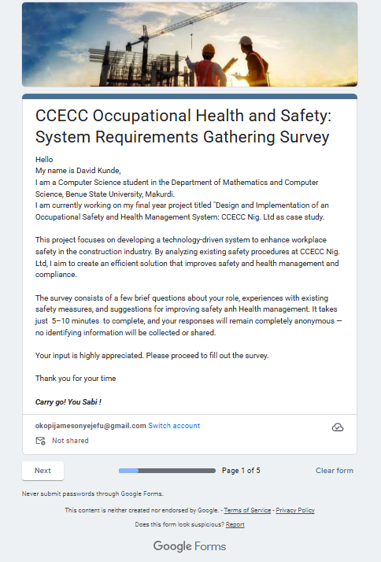

Figure 1

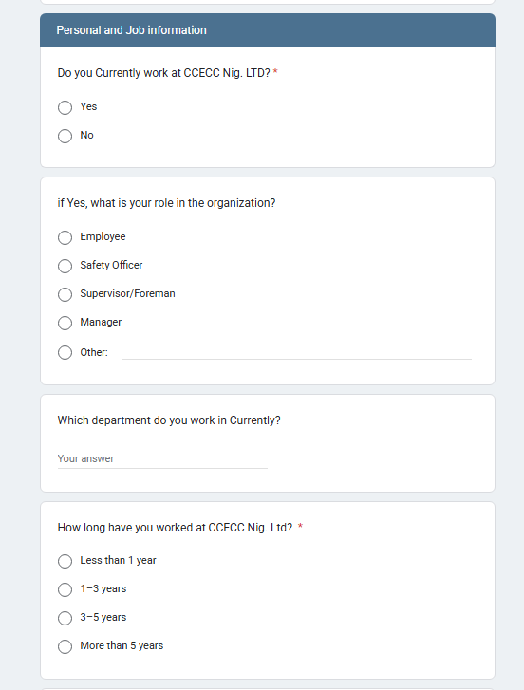

Figure 2

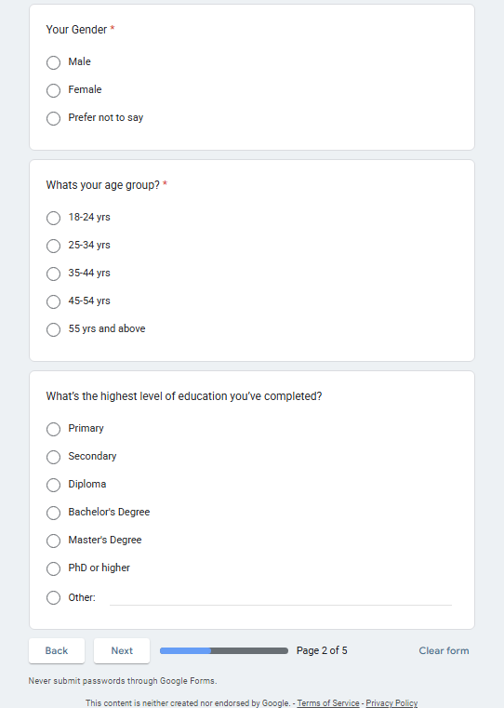

Figure 3

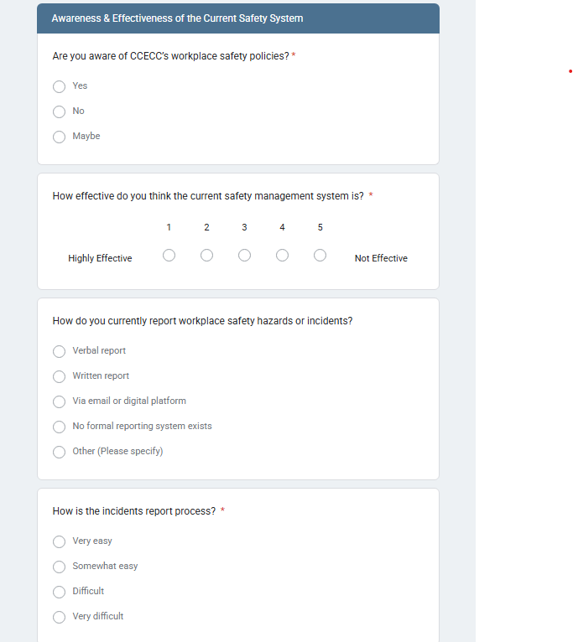

Figure 4

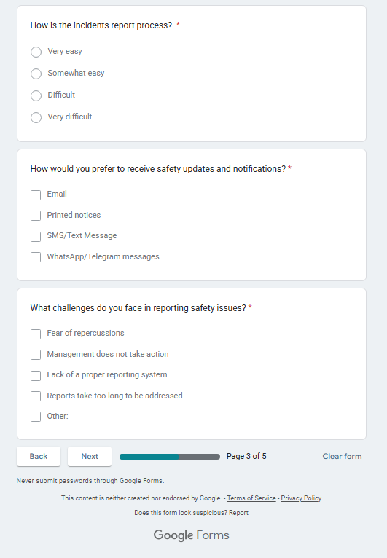

Figure 5

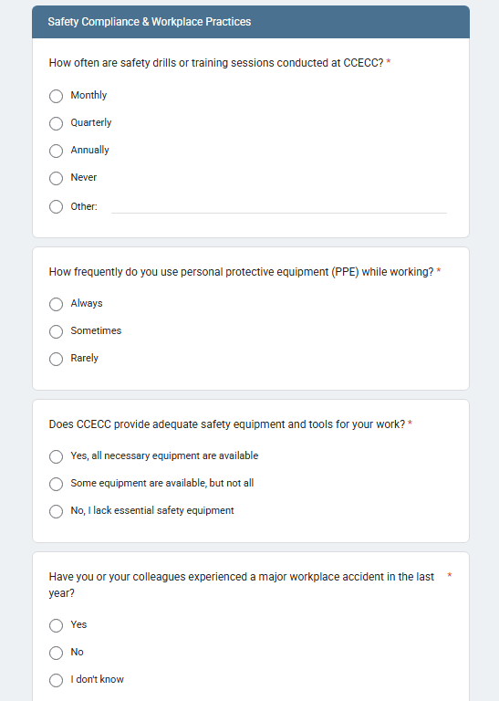

Figure 6

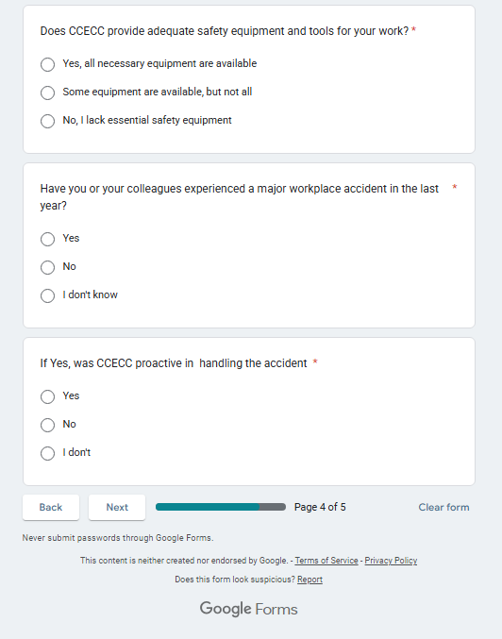

Figure 7

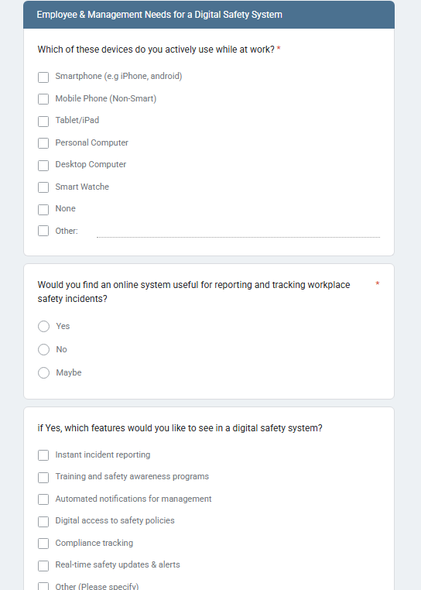

Figure 8

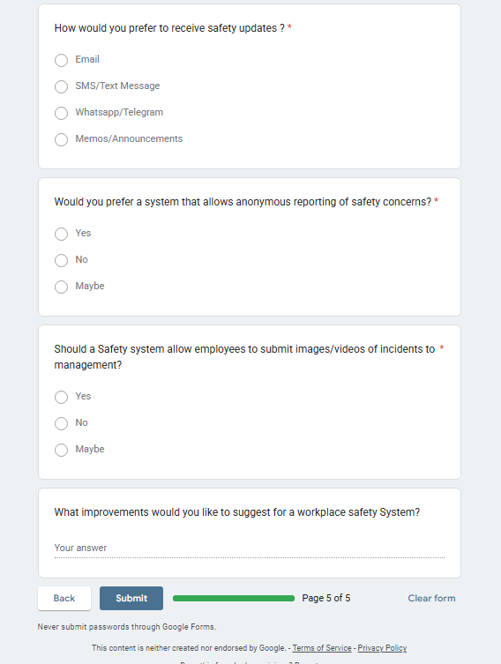

Figure 9